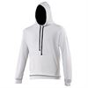  Arctic White / French Navy  S, M, L, XL, 2XL | 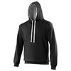  Jet Black / Heather Grey  XS, S, M, L, XL, 2XL, 3XL, 4XL, 5XL
Bottle Green / Fire Red  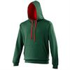  S, M, L, XL, 2XL | 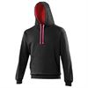  Jet Black / Hot Pink  XS, S, M, L, XL, 2XL
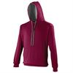  Burgundy/Charcoal  XS, S, M, L, XL, 2XL, 3XL  Burgundy/Gold  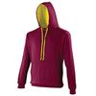  S, M, L, XL, 2XL | 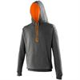  Jet Black/Orange Crush  XS, S, M, L, XL, 2XL
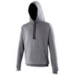  Charcoal/Jet Black  S, M, L, XL, “XL | 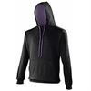  Jet Black/Purple  S, M, L, XL, 2XL
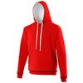  Fire Rd/Arctic White  S, M, L, 2XL | 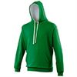  Kelly Green / Arctic White  S, M, L, XL, 2XL
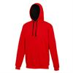  Fire Red / Jet Black  XS, S, M, L,XL, 2XL | 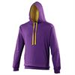  Purple / Sun Yellow  XS, S, M, L, XL, 2XL
Heather Grey / Fire Red  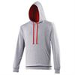  XS, S, M, L, XL, 2XL | 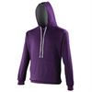  Purple/Heather Grey  S, M, L, XL, 2XL
Heather Grey / French Navy  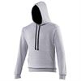  XS, S, M, L, XL, 2XL, 3XL, 4XL, 5XL | 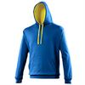  Royal / Sun Yellow  XS, S, M, L, XL, 2XL
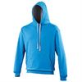  Sapphire Blue / Heather Grey  XS, S, M, L, XL, 2XL | 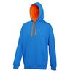  Sapphire Blue/Orange Crush  XS, S, M, L, XL, 2XL
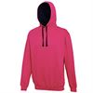  Hot Pink / French Navy  XS, S, M, L, XL, 2XL | 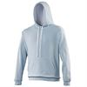  Sky / Arctic White  S, M, L, XL, 2XL
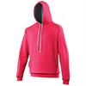  Hot Pink / Heather Grey  XS, S, M, L, XL, 2XL |  | 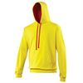  Sun Yellow / Fire Red  S, M, L, XL, 2XL
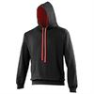  Jet Black / Fire Red  XS, S, M, L, XL, 2XL, 3XL, 4XL, 5XL |   Jet Black/ Arctic White  S, M, L, XL, 2XL
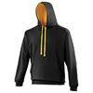  Jet Black / Gold  XS, S, M, L, XL, 2XL, 3XL | 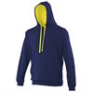  Oxford Navy/ Sun Orange  S, M, L, XL, 2XL
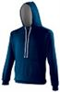  New French Navy/ Heather Grey  XS, S, M, L, XL, 2XL, 3XL, 4XL, 5XL | 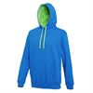  Sapphire Blue/ Lime Green  S, M, L, XL, 2XL
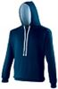  New French Navy/ Sky Blue  XS, S, M, L, XL, 2XL | 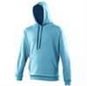  Hawaiian Blue/ Oxford Navy  S, M, L, XL, 2XL
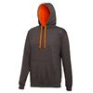  Charcoal/ Orange Crush  S, M, L, XL, 2XL |   Charcoal/ Heather Grey  S, M, L, XL, 2XL
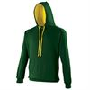  Forest Green/ Gold  S, M, L, XL, 2XL | 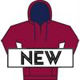  Burgundy/ Oxford Navy  S, M, L, XL, 2XL
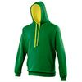  Kelly Green/ Sun Orange  S, M, L, XL, 2XL |   Heather Grey/ Jet Black  S, M, L, XL, 2XL
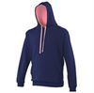  Oxford Navy/ Candyfloss Pink  S, M, L, XL, 2XL |   Heather Grey/ Sapphire Blue  S, M, L, XL, 2XL
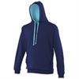  Oxford Navy/ Hawaiian Blue  S, M, L, XL, 2XL | 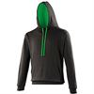  Jet Black/ Kelly Green  XS, S, M, L, XL, 2XL
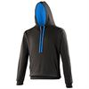
Jet Black/ Sapphire Blue
XS, S, M, L, XL, 2XL

